1.1 Recording JMeter Script



This section will guide you to:

* Record a script in JMeter

**Development Environment:**

* Apache JMeter 5.1.1 Version
* Open JDK Runtime Environment 11.0.2

This guide has five subsections, namely:

1.1.1 Configuring HTTP Script Recorder to your JMeter

1.1.2 Doing proxy settings in JMeter

1.1.3 Configuring JMeter in browsers (using Firefox browser here)

1.1.4 Recording the script

1.1.5 Pushing code to GitHub Repositories

**Step 1.1.1:** Configuring HTTP Script Recorder to your JMeter

* Open Jmeter by clicking on the JMeter icon on the desktop in your practice lab.
* Right click on Test Plan.
* Click on Thread(Users) -> Thread Group.

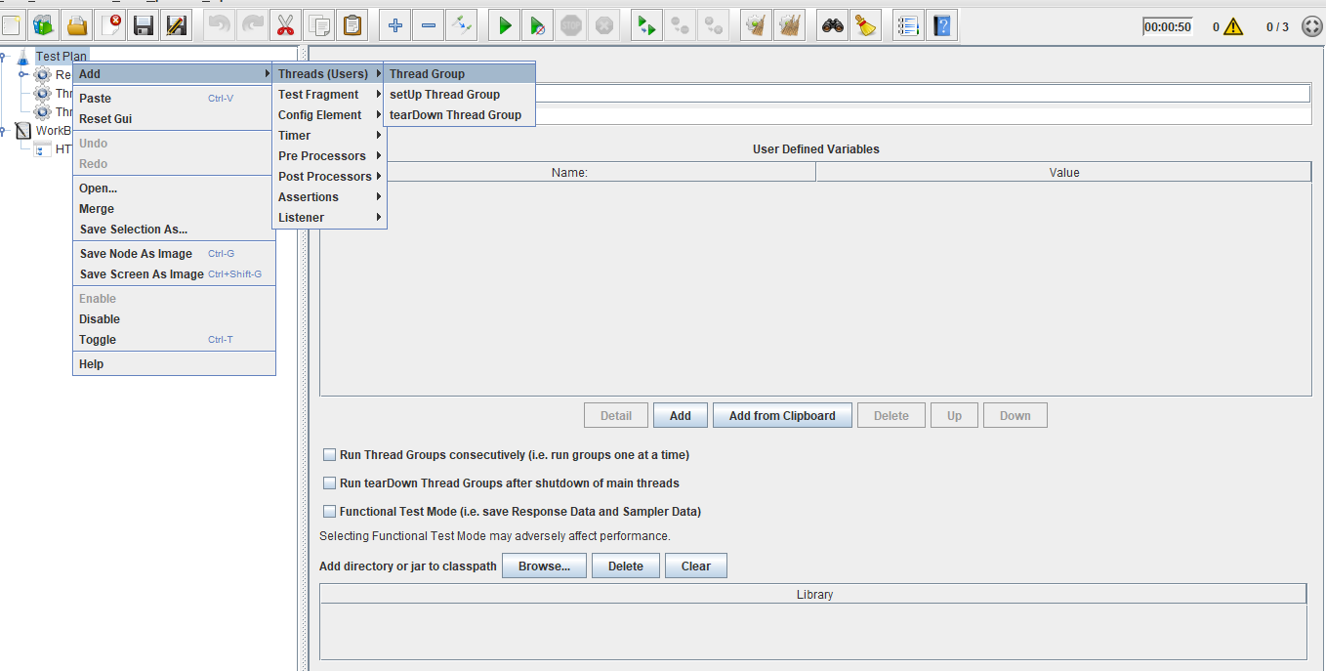

* Right click on Workbench.
* Click on Add -> NonTest Elements -> Http(s) Test Script Recorder.

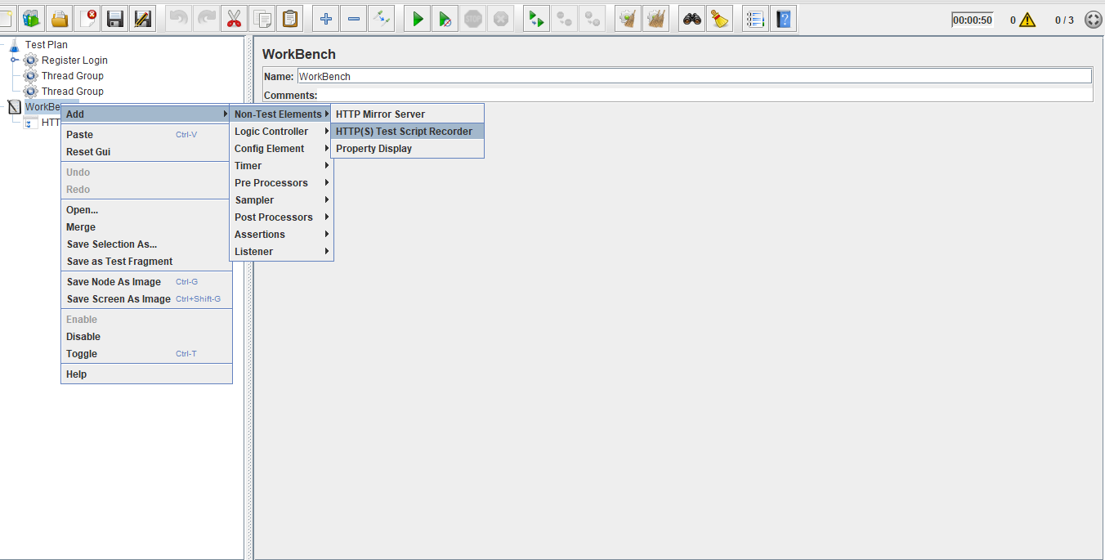

* Right click on Thread Group.
* Click on Add -> Logic Controller -> Recording Controller.

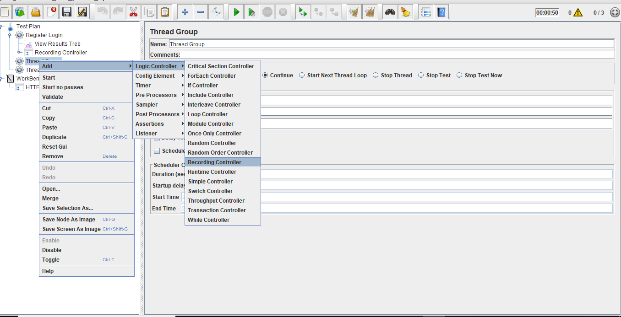

* Right click on Thread Group.
* Click on Add -> Listener -> View Result in Tree.

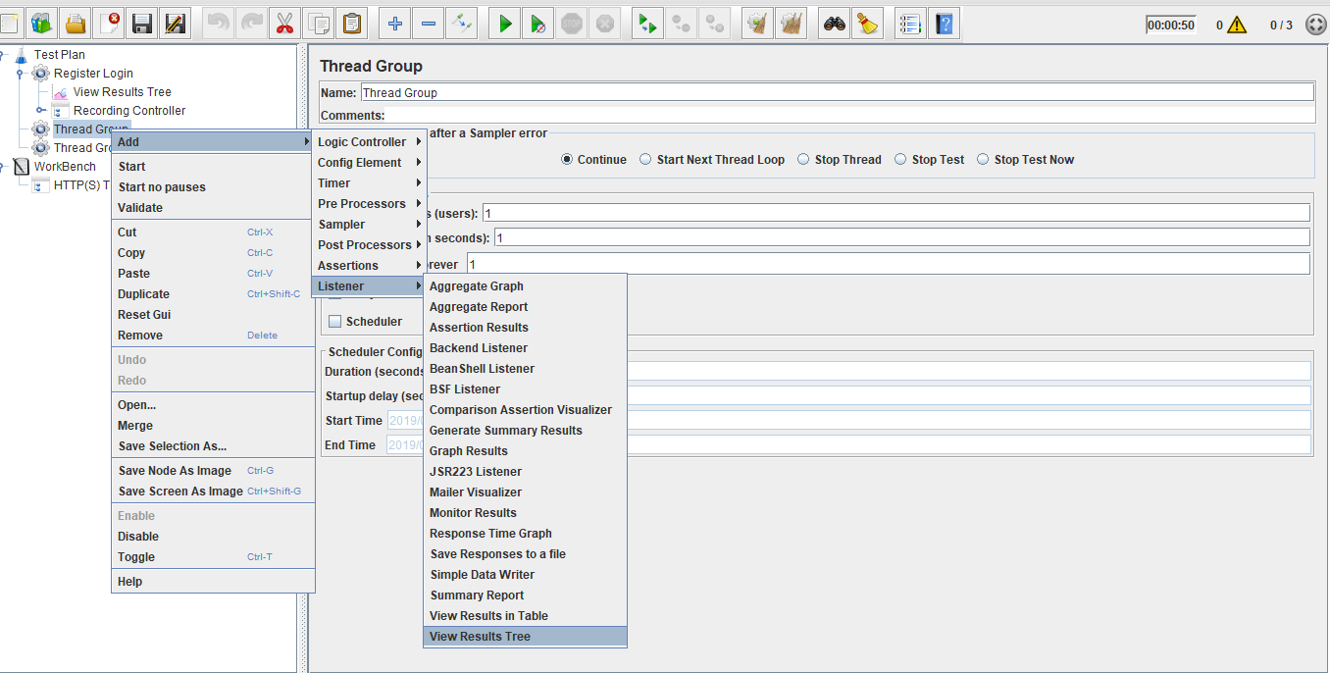

**Step 1.1.2:**  Doing proxy settings in JMeter

* Click on HTTP(S) Script Recorder.
* Set port number (optional).
* Click on the Start Button.

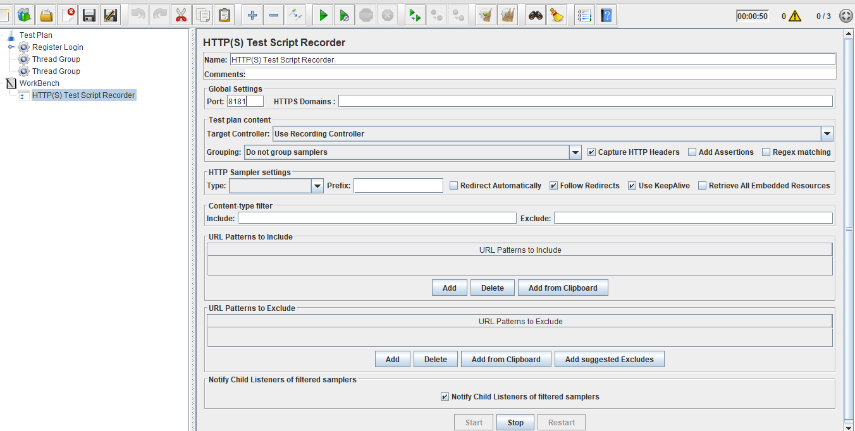

**Note:** TheDefault Certificate will be generated in your local machine.

**Step 1.1.3:** Configuring JMeter in browsers (using Firefox browser here)

* Start Firefox, but do not close JMeter.
* From the toolbar, click *Edit* → *Preferences* (or *Tools* → *Preferences* or type **about:preferences#advanced** as the URL). This should bring up the options.

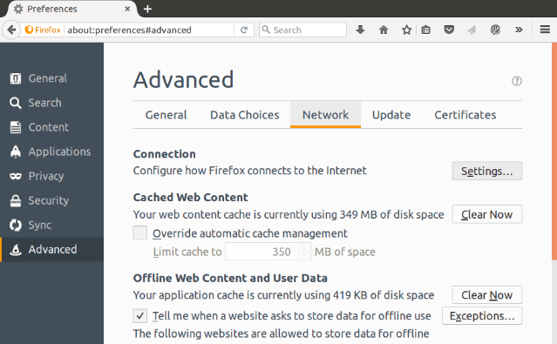

* Select the Advanced tab and Network tab.
* Click Settings Button near the top.
* On the new POP-UP, check Manual Proxy Configuration. The address and port fields should be enabled now.

Address:

Enter localhost or the IP address of your system.

Port:

Enter 8181(Samp port in HTTP(S) Script Recorder)

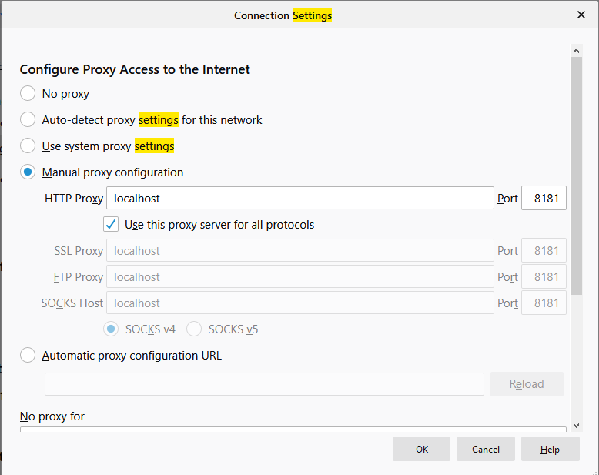

* Check the **Use this proxy server for all protocols** checkbox.
* Click the **Ok** button and that should return you to the browser.

**Step 1.1.4:** Recording the script

* Open the website you want to check in a browser, example: Firefox.
* Recording Controller records the script.

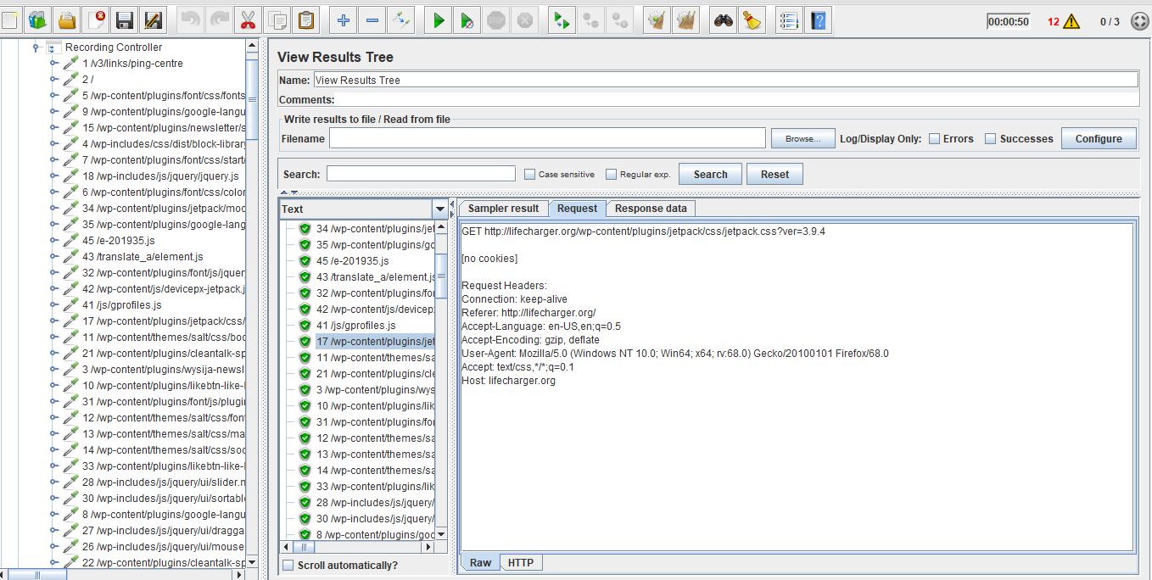

* View the results in **View Result Tree**.

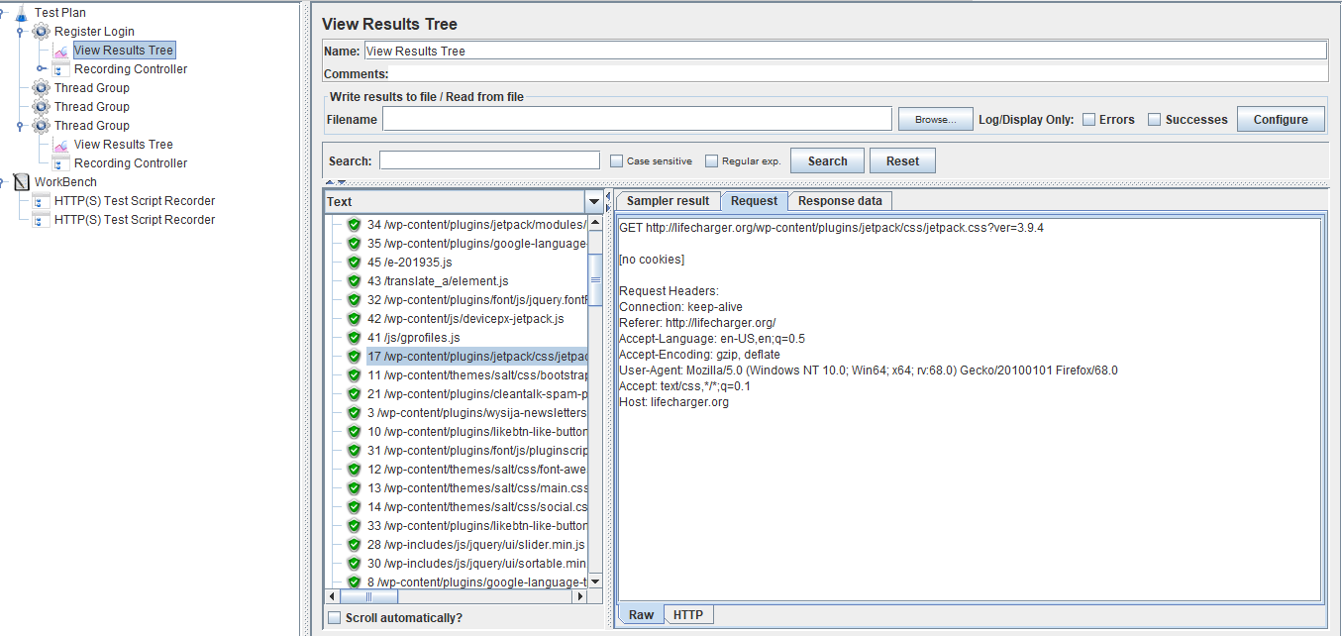

**Step 1.1.5:** Pushing the code to GitHub repositories

Open your command prompt and navigate to the folder where you have created your files.

cd <folder path>

Initialize your repository using the following command:

git init

Add all the files to your git repository using the following command:

git add . 

Commit the changes using the following command:

git commit . -m “Changes have been committed.”

Push the files to the folder you initially created using the following command:

git push -u origin master